Dashboard ZAB-AA project – Aedes and arboviruses in Belgium

*Written by Veerle for Matt (27/06/2024 – discussion of dashboard planned on 25th of July)*

Dashboard need to have two functions:

* Real time alerting of overlap mosquitoes/import cases
* Historical risks of mosquitoes and of import cases

1. Real time function (for 2024)
   1. Mosquito information (colouring a postal code):
      1. 2024 – information on a cumulative basis over 2024
      2. Scenarios 2 need to be marked: these are for 2024: Lebbeke, Puurs-Sint-Amands, Wilrijk and Kessel-Lo
   2. Imported dengue case information (coloured stars):
      1. Cases of the last week: with the mark of a red star (for example)
      2. Cases per month of 2024: to work with a different colour per month and with different size depending on number of cases for that month in that postal code
   3. Overlap : alert function when a case in the current week is detected in a postal code where the mosquito was detected in 2024
2. Historical risk function
   1. Mosquito information:
      1. Function where one can select a year to map the places where mosquitoes were found (figure 1 as example)
      2. Cumulative function where one can select the last 5 years to map places where mosquitoes were detected once/twice/3/4/5 times (figure 2 as example)
   2. Imported dengue case information (only to take the cases for the period May-October):
      1. Function where one can select a year to map the places with imported dengue cases (colour codes for categories of number of cases) (figure 3 as example)
      2. Cumulative function where one can select the last 5 years to map places with frequency of detection of cases (figure 4 as example)
3. Other activity: Propose to Marjan and Wim/Isra an excel format for easy introduction or lecture by the dashboard

**Figures:**

Figure 1. Mosquito per year (example of 2023)

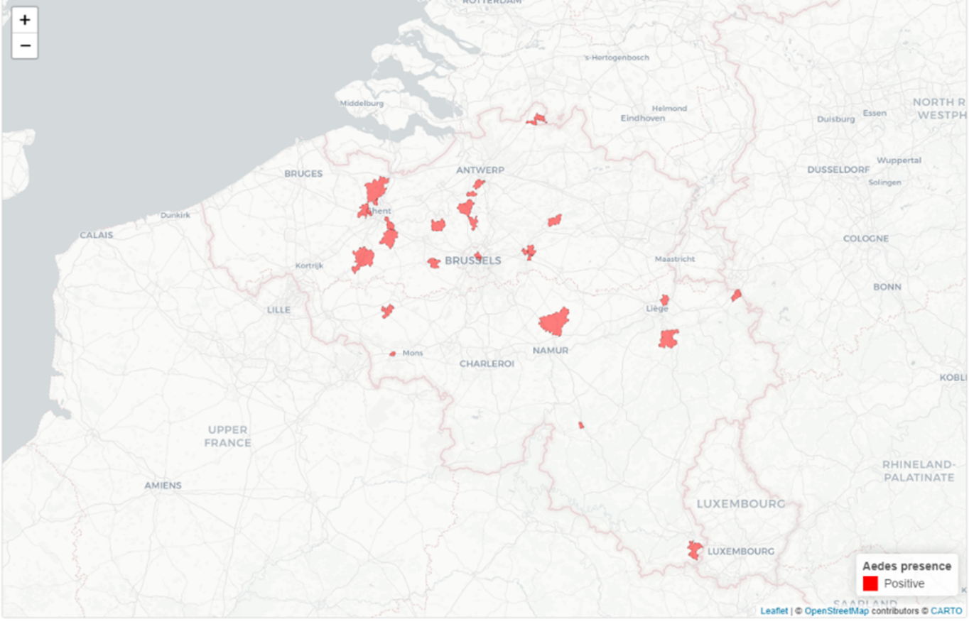

Figure 2. Mosquito per 5 years

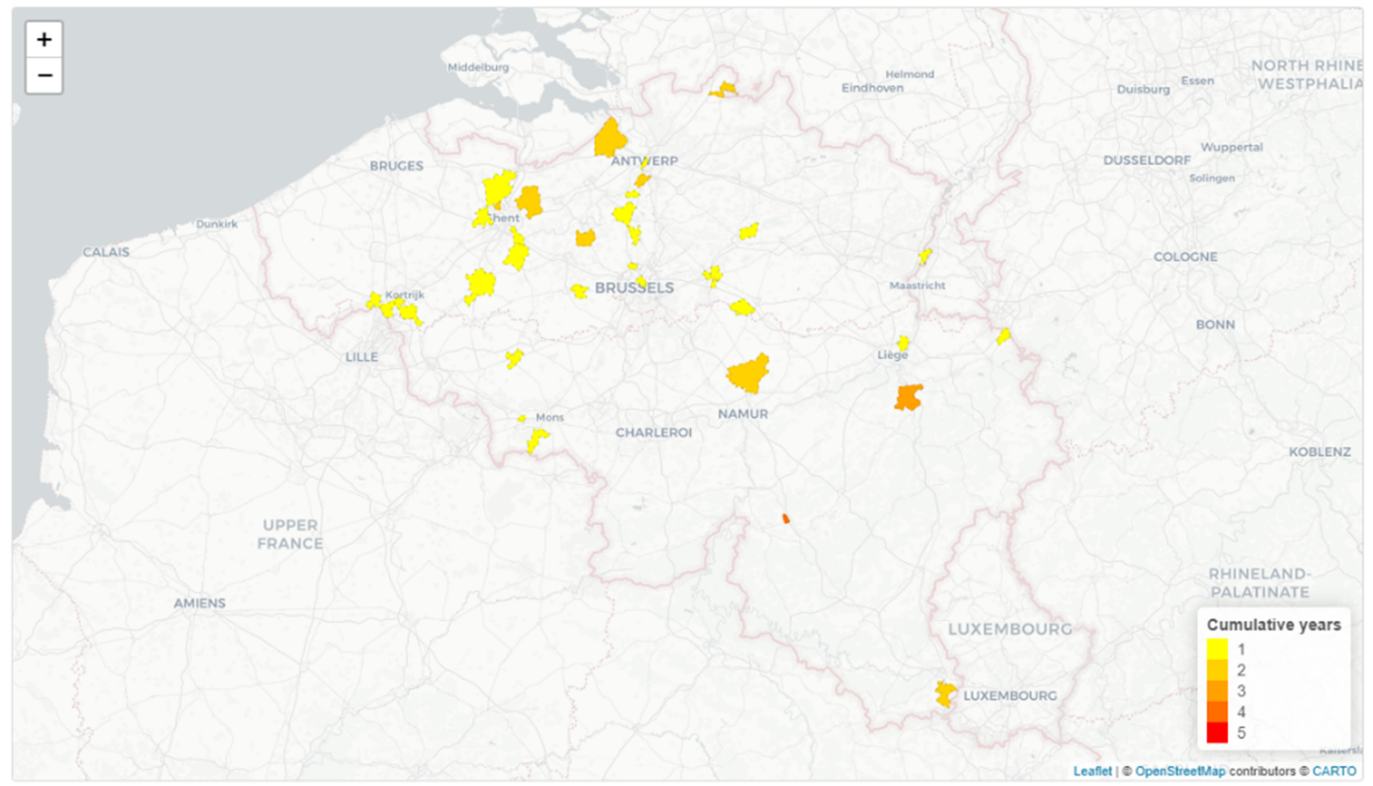

Figure 3. Imported dengue case per year (example 2023 May-October)

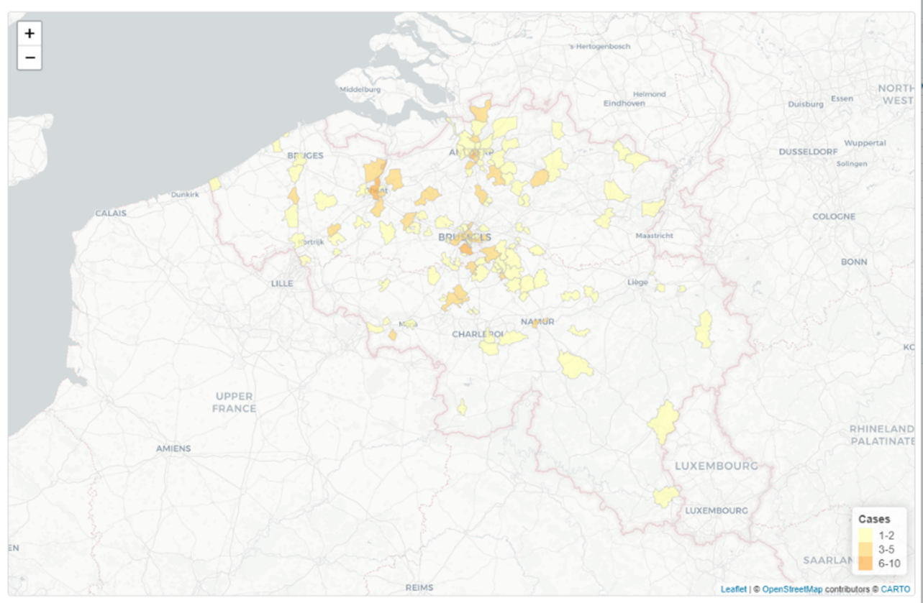

Figure 4. Imported dengue case per 5 years

